____________________________________________________________________________

Status of code / additional notes
Points / descriptions to check
Priority to check
Choice (to re-visit later or after writing code in full)
Checks
Code snippets

____________________________________________________________________________

Plotting results and improving code

To improve code:
- Re-run the monochromatic MF constraints with E_number=500, using BH_launcher (BH_launcher does not allow the number of energies to be changed. Instead I am using a program isatis_runner_mono.py to perform the same calculations).
  - Mass range: 1e11-1e21 g
  - Number of masses: 1000
  - Save these as “mono_E500”

- Update isatis_runner_mono.py to run Isatis

- Run most accurate f_PBH calculations for:
  - Using cutoff = 1e-7, E_number = 10000, dm=1e-4
  - LN
    - Results converge to calculated result with (cutoff = 1e-7, E_number = 10000, dm=1e-4)
  - SLN
    - Results converge to calculated result with (cutoff = 1e-7, E_number = 10000, dm=1e-4)
    - Isatis killed for Delta >= 2.0
  - CC3
    - Results converge to calculated result with (cutoff = 1e-7, E_number = 10000, dm=1e-4)
    - Isatis killed for Delta >= 2.0
  - I have added a Boolean to control whether to use a cutoff with:
    - cutoff = 1e-7, E_number=10000, dm=1e-4 (which doesn’t give results for all Delta >= 2.0 for the CC3 and SLN MFs)
    - cutoff = 1e-3, E_number=1000, dm=1e-4 (which gives results for all Delta and all MFs)

- Modify isatis_runner.py and isatis_runner_v2.py when using the test mass range (for comparison to constraints obtained using the method from 1705.05567 in extended_MF_checks.py), to ensure a consistent output.

- In extended_MF_checks.py:
  - Check that I can re-run the “test_mass_range” from isatis_runner.py
  - Check the results for a LN agree between the Carr et al. method and the Isatis version in extended_MF_checks.py
    - See Pictures/Mar 23/Coding tests/Isatis_Carr_extended_MF/30-3_redone.png

- Remove unnecessary tests in preliminaries.py (e.g. those estimating the peak of the SLN MF)?

- Remove the ‘duplicate’ load_results_Isatis() function that appears in convergence_tests.py, by re-writing the original in preliminaries.py so that it does not include the “GC” in “mf_string”
  - Re-do monochromatic MF constraints checks in extended_MF_checks.py
  - Check load_results_isatis() then works
  - Remove load_results_isatis () from preiliminaries.py
  - Check results work in convergence_tests.py
    - LN
    - SLN
    - CC3
  - Upload to Github
- Check previous code summary files to ensure no outstanding mistakes or problems remaining in the codes

____________________________________________________________________________

START OF PROGRAM:

Imports:
- numpy
- matplotlib
- matplotlib.pyplot
- from preliminaries, *
- from convergence_tests, load_results_Isatis
- from extended_MF_checks import envelope

Plotting results:

- Load monochromatic MF results
  - Subaru-HSC microlensing: from 2007.12697
  - Galactic Centre photon constraints: default from load_results_Isatis(modified=True) [default is mono_E500, i.e. the monochromatic MF constraints with E_number=500]

- Cycle through values of Delta

  - For SLN, CC3, LN

    - Load results for Galactic Centre photon constraints.
    - Find envelope of Galactic Centre photon constraints.
    - Load Subaru-HSC microlensing constraints.

  - Create two figures
    - One comparing CC3 and LN
    - One comparing SLN and LN

  - Calculate peak mass of the LN MF, using mp_SLN = mc_SLN * np.exp(-sigmas_LN[i]**2)

  - Plot the constraints, set axes etc.

Source of constraints:
- The GC constraints files used in the plots were calculated on my office PC, and uploaded to OneDrive
- The microlensing constraints files have been calculated on both the office PC and my laptop

Sanity checks:
Check the monochromatic MF constraints match those from the modified version of Isatis (quick visual check)

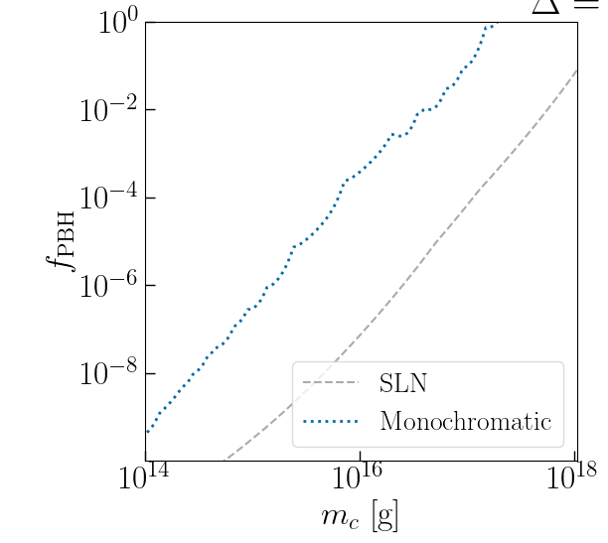

Modified version of Isatis
Unmodified version of Isatis
The version of the monochromatic MF constraints appearing in the plots looks close to the modified version of Isatis. It does not have the feature around ~a few times 10^15 g that appears in the unmodified version of Isatis.

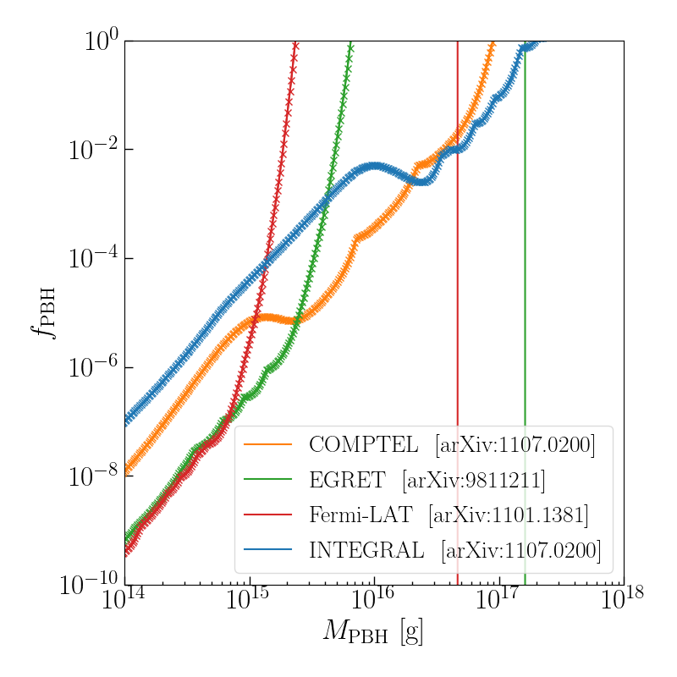
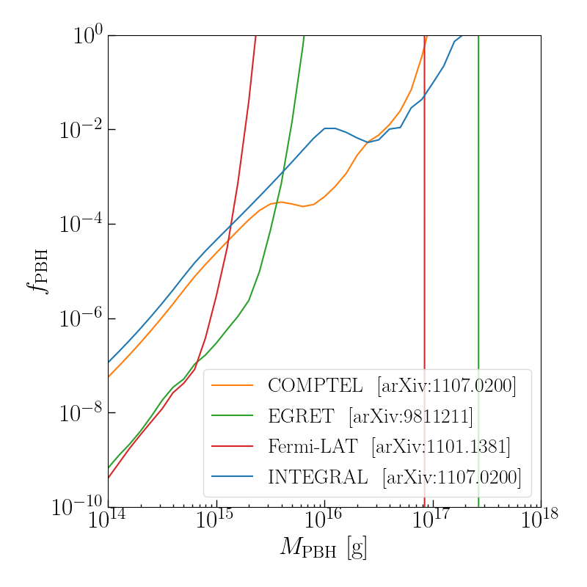

Understanding the effects of evaporation on constraints

CC3 MF (Delta=2.0):

f_PBH = 1 occurs at:
- m_p = (2.3e17g, 3.2e21g)

Largest value of m_p for which psi(m_p, m= M_* = 5e14g)/psi_max > 1e-4
- m_p = 2.7e16g

SLN MF (Delta=2.0):

f_PBH = 1 occurs at:
- m_c = (7.4e17g, 1.0e22g)

Largest value of m_c for which psi(m_c, m= M_* = 5e14g)/psi_max > 1e-4
- m_c = 8.7e16g

With a cutoff in psi/psi_max of 1e-4, there is no effect on the constraints at the edge of the asteroid-mass window.

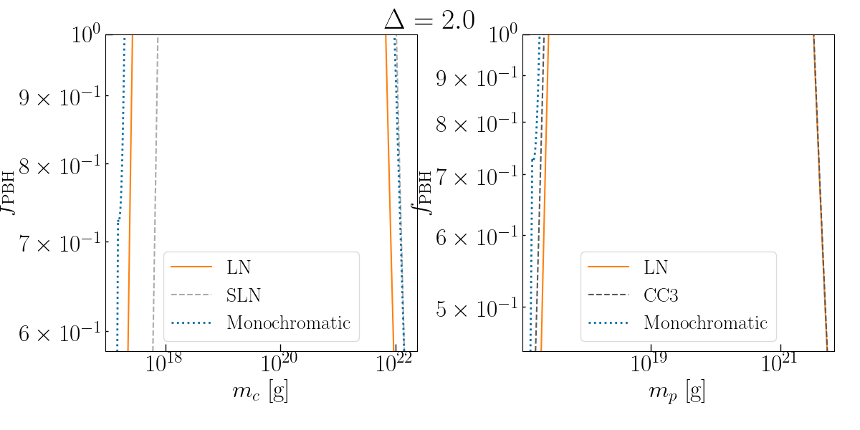

CC3 MF (Delta=5.0):

f_PBH = 1 occurs at:
- m_p = (6.2e17g, 4.8e19g)

Largest value of m_p for which psi(m_p, m= M_* = 5e14g)/psi_max > 1e-4
- m_p = 1.9e18g

SLN MF (Delta=5.0)::

f_PBH = 1 occurs at:
- m_c = (2.3e18g, 7.4e19g)

Largest value of m_c for which psi(m_c, m= M_* = 5e14g)/psi_max > 1e-4
- m_c = 4.7e18g

The values of the CC3 and SLN MFs at m=M_* is larger than the cutoff of 1e-4, in the range where the constraint f_PBH = 1.

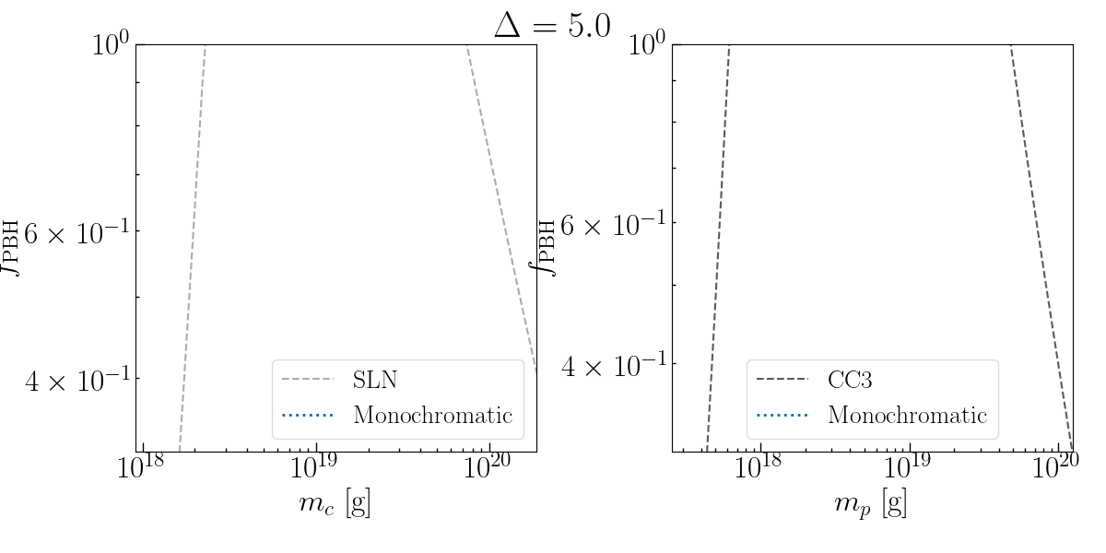

Plotting all results against peak mass m_p rather than m_c for LN/SLN:

Reason for plotting against peak mass: it is a physical quantity, rather than a parameter for a fitting function.

From preliminaries.py, there is a test to compare the peak mass of the skew-lognormal with different mass ranges
- The calculations suggest that for all Deltas, and all MFs, the value of m_p can be obtained to within 10% of the most accurate value using n_steps = 1e2 and log_m_range = 1
- Checked using the m_c values and m_p values from Table II of 2009.03204 (for Delta=0 and Delta=5)
- Checked using other values of m_c to ensure reasonable MF ranges

- To calculate m_p to within 1% the most accurate value can require significantly more steps and ranges of masses, the widest range being n_steps = 1e3, log_m_range =4

For safety, I will plot the results using n_steps = 1e3, log_m_range = 4

